|  |  |  |
| --- | --- | --- |
|  | **CAN THO UNIVERSITY SOFTWARE CENTER** |  |
| **MEKONG DELTA - APTECH** |

**SEMESTER III**

**ONLINE BOOK STORE**

|  |  |
| --- | --- |
| **Instructor:** | **Class: CP2396H04** |
| Mr. Thai Nguyen Vo Thong | **Group: 01** |
| **Students:**   1. A22082 – THI NGUYEN NGOC BAO 2. A20084 - LOC DINH HUU 3. A22092 - QUYNH NGUYEN DUONG KIEU DIEM |

Can Tho, 12/2023

This is to certify that

**Ms:** Nguyen Ngoc Bao Thi

**Mr:** Dinh Huu Loc

**Ms:** Nguyen Duong Kieu Diem Quynh

Has successfully Design & Developed

Submitted by:Nguyen Ngoc Bao Thi

Date of Issue: 15/01/2023

Authorized Signature: Nguyen Vo Thong Thai

**PROJECT PROBLEM DEFINITION**

Shradha General Book Store, our esteemed customer, is a well-known reseller specializing in a wide range of books and related materials. The store boasts an extensive and varied collection, offering customers a wide selection including stories, textbooks, notebooks, essay writing materials, contest preparation books (such as General Knowledge and Essay Writing), novels, language learning resources, and various book-related accessories such as covers, pens, pencils, etc. In addition, the store offers searched items such as books and files.

Currently, our customers operate in a system of shopping and selling craft books. The client deals directly with some publications to purchase books, and for some he purchases books through other agents. In addition, some booksellers and agents purchase books from our customers. Customers, whether going to a physical store or ordering via phone calls, experience delays due to the absence of automation in the system, resulting in dissatisfaction. With a growing number of small-scale publishers and agencies, transactions have become more complex, making customer retention difficult.

In response to these challenges and to remain competitive in the growing market, Shradha General Book Store have taken strategic measures. These include discounts on bulk orders and home delivery services with free delivery within a radius of 3 km. Beyond this radius, fees will apply based on the selected delivery service.

To revolutionize the business and address these pain points, our customers envision the integration of an online sales system. The goal is to streamline the ordering process, minimize delays, and improve customer satisfaction. Realizing the need for a robust digital solution, the client approached us to develop a comprehensive website. Understanding the desires of customers, the Online Book Store website has been created to establish an online platform that caters to the needs of its users and aims to provide satisfying shopping experience to customers in an increasingly competitive market today.

The main menu consists of the following sections:

*Customer

- Categories

- Home

- Shop

- About Us

- Contact

- Order Tracking

- Favourite

- Cart

- Customer Account

*Admin

- Products management.

- Customers management.

- Orders management.

- Bills management.

- Categories management.

- Subcategories management

- Payments management

- Suppliers management.

- Authors management.

- FAQs management.

- Feedbacks management.

**Customer Requirements Specification (CRS)**

**Client:** Shradha Online Book Store

**Business/Project Objectives:**

Building the Online Book Store website with the aim of being able to provide customers who can directly interact and place orders through online purchases, fastest without having to return to the store in person.

**Input provided by the Customer:**

**System-related processes:**

1. **Admin:**

* Login:
* Description: Sign in to your account to manage your store.
* Input: Administrator email and password.
* Output: Notification of results after login.
* Product:
* Description: Add/edit/remove/search and display product information.
* Input: Product ID, Category ID, Author ID, Manufacturer ID, Name, Quantity, Price, Image, Description, Release Date.
* Output:
* If filled in correctly: Announce results after add/edit/delete/search for product information.
* If entered incorrectly : will report an error.
* Managed provider:
* Description: Add/edit/delete/search and display supplier information.
* Input: Supplier ID, company name, contact name, address, phone, fax, and supplier contact web address.
* Output:
* If filled in correctly: Report results after add/edit/delete/search provider information.
* If entered incorrectly : will report an error.
* Employee:
* Description: Add/edit/delete/search and display employee information.
* Input: Employee ID, employee's full name, status: working or inactive, department name, role, role name, phone, email, password, address, employee creation date, and employee update date.
* Output:
* If entered correctly:Announce results after add/edit/delete/search and display employee information.
* If entered incorrectly : will report an error.
* Directory:
* Description: Add/edit/delete and display catalog information.
* Input:Category ID, category name.
* Output:
* If entered correctly: Announce the result after add/edit/remove category information.
* If entered incorrectly : will report an error.
* Subcategories:
* Description: Read/delete/search and display subcategories.
* Input: Subcategory ID, subcategory name.
* Output:
* If entered correctly:Message results after add/edit/delete subcategory information.
* If entered incorrectly : will report an error.
* Managed customer feedback:
* Description: Read/delete/search and display customer feedback.
* Input: customer feedback ID, account id, staff id, customer feedback, admin reply, date customer feedback submitted.
* Output:
* If entered correctly: Announce the result after delete/look up customer feedback and displaying the feedback.
* If entered incorrectly : will report an error.
* Managed orders:
* Description: Details/delete/search, display order information and status.
* Input: Order ID, customer id, payment plan detail id, order status, phone number, address, customer address details, number of connections, order date.
* Output: Announce results after delet/look up information and order status.
* Author:
* Description: Add/edit/delete/search and display author information.
* Input: Author ID, author name, description.
* Output:
* If entered correctly:Message results after add/edit/delete/search author information.
* If entered incorrectly : will report an error.
* Order:
* Description: Add/edit/delete/search and display order information.
* Input: order ID, customer ID, product ID, payment method ID, customer information, shipping fee, total amount, customer note.
* Output:
* If entered correctly: Announce results after add/edit/delete/search order information.
* If entered incorrectly : will report an error.
* Customer:
* Description: Edit/delete/search and display customer information.
* Input: Customer ID,username, phone number, email, password, address,gender, of the customer.
* Output:
* If entered correctly: Announce results after add/edit/delete/search and display customer information.
* If entered incorrectly : will report an error.
* Payment methods :
* Description: Add/edit/delete/search/payment method information.
* Input: Payment method ID, payment method name.
* Output:
* If entered correctly: Message the result after add/edit/remove/search/payment method information.
* If entered incorrectly : will report an error.
* FAQ page:
* Description: Add/edit/delete/information questions.
* Input: questions from users, customer feedback data.
* Output: Displays the results of add/edit/delete questions.
* **Home page:**
* Login:
* Description: Sign in to the customer's account to view and make purchases.
* Input: client username and password.
* Output:
* If entered correctly: Report the result after signing in.
* If entered incorrectly : will report an error.
* Register:
* Description: Sign customer information to view and purchase.
* Input: username, email, phone, password, address,gender.
* Output: Announce the result after registration.
* Product Page:

✧ Description: Details/more, display product information.

✧ Input: Product details, publisher, price, image of the product.

✧ Output: Displays the details of the product.

* Order tracking:
* Description: Display information and track orders.
* Input: Order information, order status.
* Output: Order details, status and updates, shipping information.
* Feedback:
* Description: Customers can give product feedback.
* Input: Opinions and reviews, detailed customer comments.
* Output: Display feedback, improve the product.
* FAQ page:
* Description: Customer asks a question for the web.
* Input: Opinions and reviews, detailed customer comments.
* Output: Display feedback, improve products and services of the web.
* Cart :
* Description: Show/remove/add products that customers selected.
* Input: Information, price, and quantity of the product in the cart.
* Output: Announce the result after delete/add and detail the products.
* Exposure:
* Description: Displays the contact information of the website.
* Input: Address, phone number, fax, email of the website.
* Output: Display contact information.
* About us:
* Description: A display that provides information about the site.
* Input: Information, core values and vision, images and videos about the website.
* Output: Shows an overview and completeness of the website.
* Product Category:
* Description: Displays the categories of the product.
* Input: Classification, path, link to desired product.
* Output: Display to the product you want to see, deliver the product.

**Estimated delivery date:**

January 15, 2024

**List of deliverable products:**

Document:

+ Problem definition

+ Customer Requirements Specification (CRS)

+ Architecture and design

+ Flowchart

+ Data flow diagram

+ Entity relationship diagram (ER)

+ Database design/structure

+ Task board

+ Validation checklist

+ Application checklist

Database.

The source code of the website.

User manual installation

|  |  |  |
| --- | --- | --- |
|  | **Customer** | **Server** |
| **Hardware requirements** | 8GB of RAM or better | 8GB of RAM or more, 128GB storage, Pentium 166 or more |
| **Software requirements:** | Web browser | Microsoft SQL Server 18,  .NET 4.8 and IIS Server |

Instructions for use

**Architecture and design of the project:**

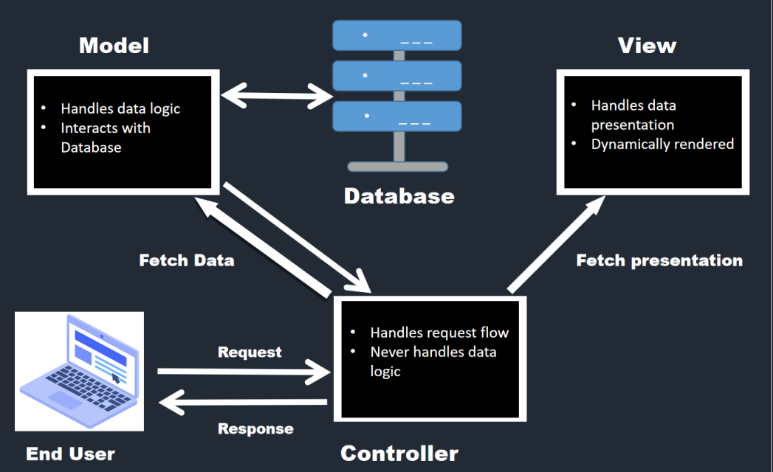

**UML diagram:**

1. **Use case diagram:**

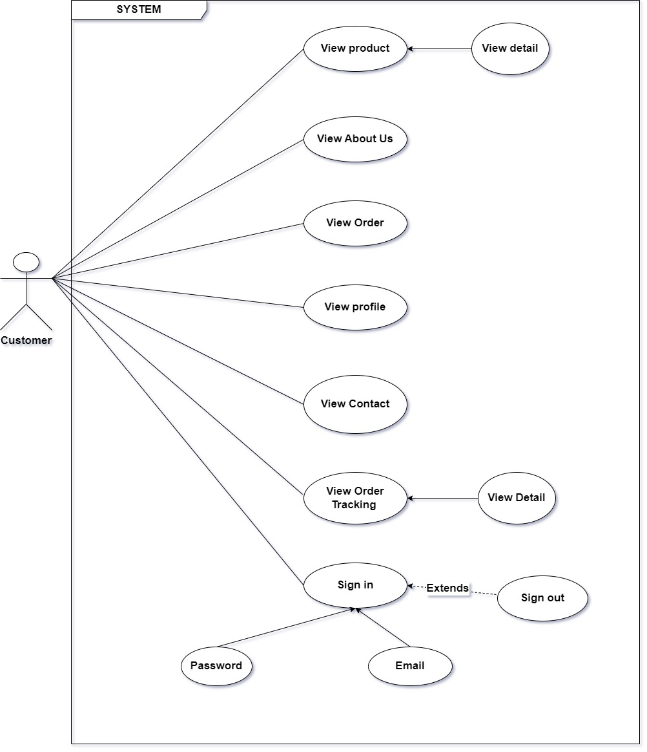

Use Case Diagram Customer

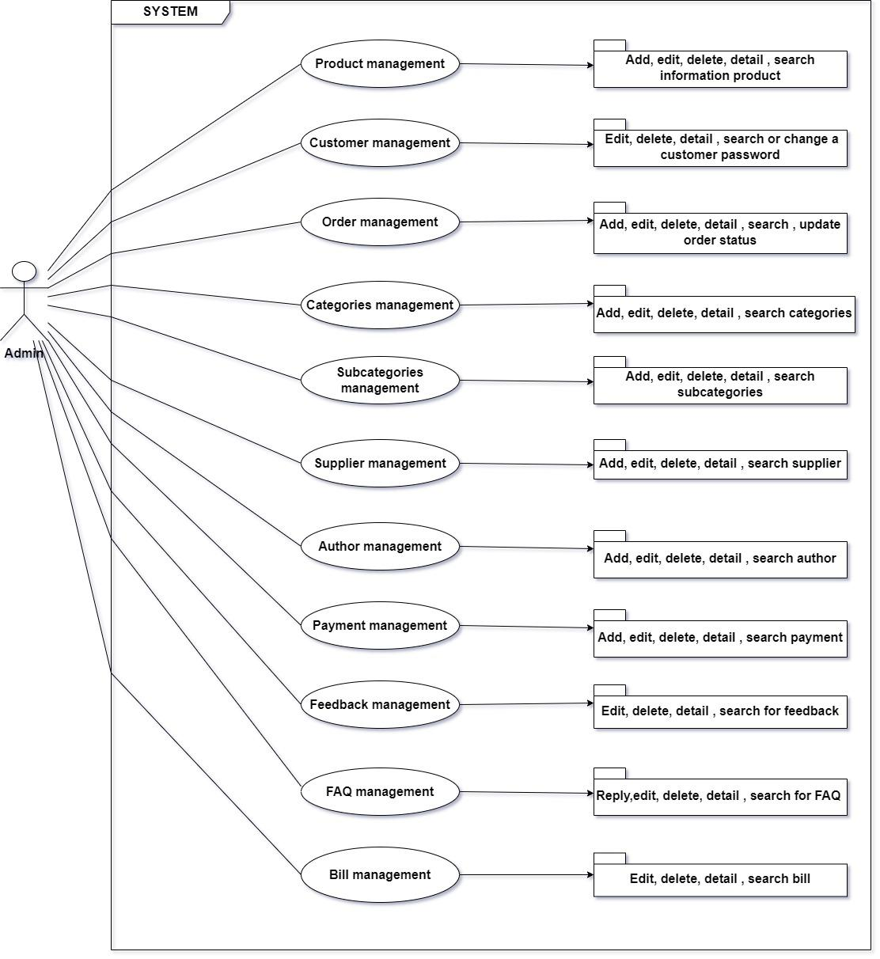

Use Case Diagram Admin

* **Use case specification:**

|  |  |  |  |  |
| --- | --- | --- | --- | --- |
| **Use case name** | **User Audience (Actors)** | **Description** | **Steps to follow** | **Prerequisites** |
| Products management use case | Admin (manager) | This use case is used to manage products to Shradha Book Store. | + Administrators click on "Products" to see the products list.  + The admin click "search" and enter information such as product name, price,... to quickly find the product you are looking for.  + Admin click "Add new product" and fill in the necessary information such as productID, productName,... to be able to create a new product. Add new successfully, the system will send the message "Add successful" and will add new product to the data.  + Or admin can click "Edit" to be able to edit the product information you want to edit, then click "Update" for the system to update data.  + Click "Remove" if you want to delete product information. The system will send a message asking for confirmation when deleting. To delete, press "OK", cancel the operation, press "Cancel".  + The above operations will be updated by the system and save data if there are new changes. | The management account must be an Admin.  Admin must have an internet connection when logging in. |
| Orders management use case | Admin (manager) | This use case is used to manage customer orders | + Admin click "Order management" to see the list of orders.  + Admin can click "Add New Order" to create a new order when the customer requests. When entering all the necessary information, the actor clicks the "update" button so that the system updates the new data.  +Admin can click "Edit" and enter the information to be edited. After editing, click "update" to update the data.  + Admin can press "Delete" to delete the order. The system will send a message asking for system confirmation when deleting. To delete, click "OK", to cancel the operation, click "Cancel".  + The system will check each information and send notifications to each function when admin perform a certain function. | The management account must be an Admin.  The admin device was connected to the internet when using the function. |
| Use case feedbacks | Customers who purchased products of Shradha Book Store | This use case allows for Shradha Book Store product quality feedback | + Customers need to log in to their account and buy products of Shradha Book Store.  + After purchasing the product, the customer click "track order", click "feedback" to respond to the product.  + To send feedback, customers need to fill in the form and fill in the content they want to respond to in the feedback form of the system and select "Submit" to submit. | Customers must log in to their account and purchase products.  The customer device must be connected to the internet when using this function. |
| Payments Management use case | Admin (manager) | This use case allows the actor to manage the payment of the Shradha Book Store. | + When the admin click "Payments management" the payments list will be displayed, along with the functions of adding a new payment plan, search, details.  + When the admin presses "Add new payment" and fully enter the new payment information, the system will store the information and update the new data.  + When the admin need to edit payment information, admin click "edit" to edit, then tap "Update" to update.  + Admin can press "Delete" to delete the payment. The system will send a message asking for system confirmation when deleting. To delete, click "OK", to cancel the operation, click "Cancel". | The management account must be an Admin.  The admin device must be connected to the internet when using this function. |
| Customers ManagementUse case | Admin  (Manager) | This use case allows the Admin to update customers, which may or may not be connected | + Admin click on "Customers management" to see the customers list.  + The admin click "search" and enter information such as customer name, information,... To quickly find the customer you need to find.  + Or admin can click "Edit" to be able to edit the customer information you want to edit, then click "Update" for the system to update data.  + Click "Delete" if you want to delete customer information. The system will send a message asking for confirmation when deleting. To delete, press "OK", cancel the operation, press "Cancel".  + The above operations will be updated by the system and save data if there are new changes. | The management account must be an Admin.    The actor's device must be connected to the internet when using this function. |
| Categories ManagementUse case | Admin  (Manager) | This use case is used to manage categories for Shradha Book Store. | + Admin click on "Categories Management" to see the list of categories.  + Admin press "search" and enter information such as categoryID, category, Name,... to quickly find the categories you're looking for.  + Admin click "Add new category" and fill in the necessary information such as categoriesID, categoriesName,... to be able to create a new category. Add new successfully, the system will send a "Add successful" message and will add new categories to the data.  + Or admin can click "Edit" to be able to edit the category information you want to edit, then click "Update" for the system to update data.  + Click "Delete" if you want to remove category information. The system will send a message asking for confirmation when deleting. To delete, press "OK", cancel the operation, press "Cancel".  + The above operations will be updated by the system and save data if there are new changes. | The management account must be an Admin.  The admin device must be connected to the internet when using this function. |
| SubcategoriesManagement Use case | Admin  (Manager) | This use case is used to manage subcategories for Shradha Book Store. | + Admin click on "Subcategories" to see a list of subcategories.  + Admin click "search" and enter information such as subcategoriesID, subcategories Name,... to quickly find the subcategories you're looking for.  + Admin click "Add new subcategory" and fill in the necessary information such as subcategoriesID, subcategoriesName,... to be able to create a new subcategory. Add new successfully, the system will send a "Add successful" message and will add new subcategory to the data.  + Or admin can click "Edit" to be able to edit the subcategory information you want to edit, then click "Update" for the system to update data.  + Click "Delete" if you want to delete subcategory information. The system will send a message asking for confirmation when deleting. To delete, press "OK", cancel the operation, press "Cancel".  + The above operations will be updated by the system and save data if there are new changes. | The management account must be an Admin  The actor's device must be connected to the internet when using this function. |
| Suppliers Management use case | Admin (manager) | This use case is used to manage suppliers who supply products to Shradha Book Store | + Admin click on "Suppliers management" to see the list of suppliers.  + Admin click "search" and enter information such as supplier name, ID,... to quickly find the supplier you're looking for.  + Admin click "Add new supplier" and fill in the necessary information such as: Supplier name, fax ,... to be able to create a new supplier. Add new successfully, the system will send the message "Add successful"  + Or admin can click "Edit" to be able to edit the supplier information you want to edit, then click "Update" for the system to update data.  + Click "Remove" if you want to delete provider information. The system will send a message asking for confirmation when deleting. To delete, press "OK", cancel the operation, press "Cancel".  + The above operations will be updated by the system and save data if there are new changes | The management account must be an Admin.  Admin must have an internet connection when logging in. |
| Authors ManagementUse cases | Admin (manager) | This use case is used to manage Authors of books to Shradh Book Store | + Admin click on "Authors management " to see the list of authors.  + Admin click "search" and enter information such as full name, information,... To quickly find an author , you need to search.  + Admin click "Add new author" and fill in the necessary information such as first name, first and last name ... to be able to create a new author. Add new successfully, the system will send the message "Add successful"  + Or admin can click "Edit" to be able to edit the author information you want to edit, then click "Update" for the system to update data.  + Click "Remove" if you want to remove author information. The system will send a message asking for confirmation when deleting. To delete, press "OK", cancel the operation, press "Cancel".  + The above operations will be updated by the system and save data if there are new changes | The management account must be an Admin.  Admin must have an internet connection when logging in. |
| Bills management use case | Admin  (manager),customers can view bill. | This use case allows Admin to check bill, update additional charges, and send them to customer. | + Admin who click"Bills management" will display a list of bills.  + After the bill is charged from the customer's account, it is transferred to the bill page. Here, the Admin can check the information and click "Edit" to edit the necessary information and click "Go to account" to transfer the bill to the customer's account.  + When you need to delete the bill subject, click "Remove" to perform the bill deletion operation. | The management account must be an Admin.  The customer must register the connection and an bill must be created before management.  The admin device must be connected to the internet when using this function |
| FAQs Management Use case | Admin  (Manager) | This use case allows Admin to answer customer questions | + Admin click on "FAQs management" to see the list of customer questions.  + Admin click "reply" to answer customer question. After answering the customer question, click "Answer" to answer the customer. The data will be sent to the customer in the FAQs page.  + Or admin can click "Edit" to be able to edit the answer they want to correct, then click "Update" for the system to update data.  + Click "Remove" if you want to delete your question. The system will send a message asking for confirmation when deleting. To delete, press "OK", cancel the operation, press "Cancel".  + The above operation will be updated by the system and save data if there are new changes. | The management account must be an Admin.  The Admin device must be connected to the internet when using this function |
| View Profile | Customer | This use case allows customers to view details about their account. | + Customer click on the account to view account information. If customer want to change any information, they should click "Edit". After making the changes, click "OK". | Customer must log in/register an account.  The customer device must be connected to the internet when using this function |
| View About Us | Customer | This use case allows customers to view the information of the Shradha Book Store. | + Customer click "About Us" to view Shradha Book Store information. | The customer device must be connected to the internet when using this function |
| View feedback | Customer | This use case allows customers to give feedback on product quality. | + After purchasing the product, the product status will show order tracking. When the order is in the received state, the customer clicks “Received", the customer can respond to the product (quality product feedback,...) | The customer device must be connected to the internet when using this function. Customers must log in to their account and purchase products. |
| Contact | Customer | This use case lets customers know where to contact. | + Customers click "Contact"  + Customers can contact Shradha Book Store via phone number, address,... | The customer device must be connected to the internet when using this function |
| FAQ | Customer | This use case allows customers to ask questions to Shradha Book Store | + Customers click "FAQ"  + Customers can ask questions to Shradha by filling in the form. After clicking "Submit". | The customer device must be connected to the internet when using this function |
| Order | Customer | This use case allows customers to add products to their cart and checkout. Customers can view order details. | + Customers add products to cart and follow checkout steps.  + After successful order. The customer clicks "Place Order" to view order details and track the order. | Customers must log in/register an account and purchase products.  The customer device must be connected to the internet when using this function |
| Account | Customer | This use case helps customers register/log in to an account. | + Customers click "Account" to register/log in to their account.  + If the customer does not have an account. Click "register", fill out the required information in the form. After filling in the information, click "Register" to create an account.  + If the customer has an account, log in to the account by entering the email and password. Click "Login" to log in to your account. If the information is correct, the client logs on successfully. If the information is incorrect, the customer must fill it out again. | The customer must register an account, and after successful registration, log in to the account.  The customer device must be connected to the internet when using this function  Customers do not leak account information to each other. |

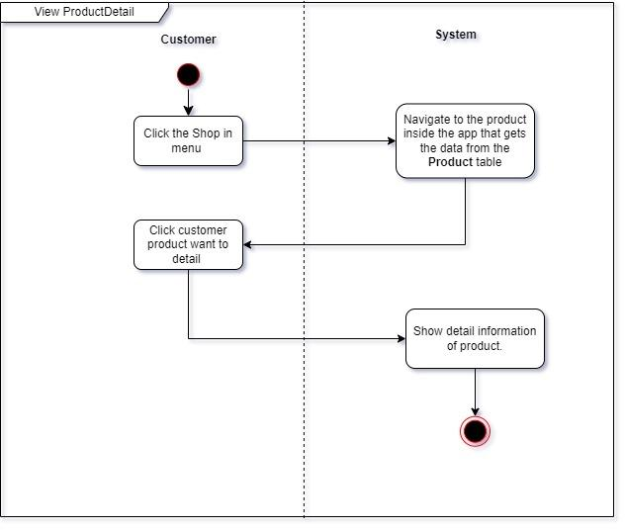

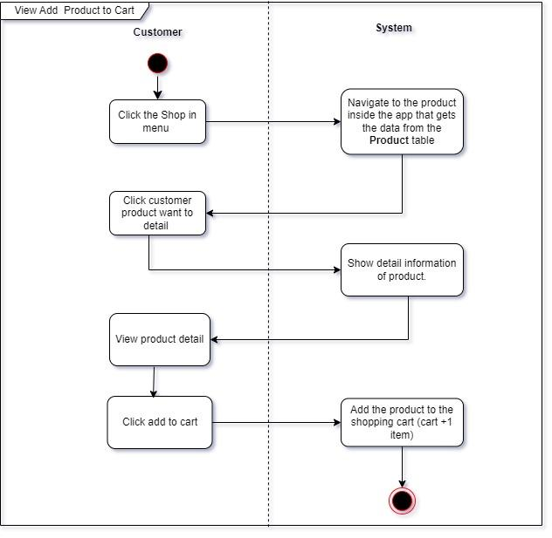

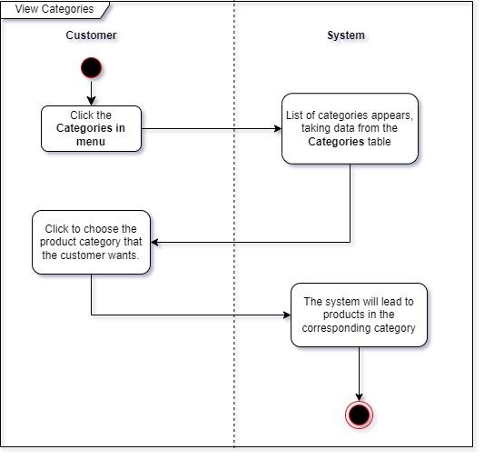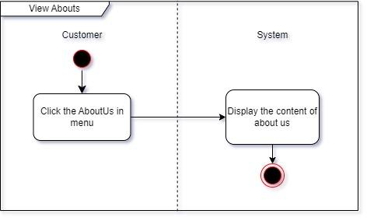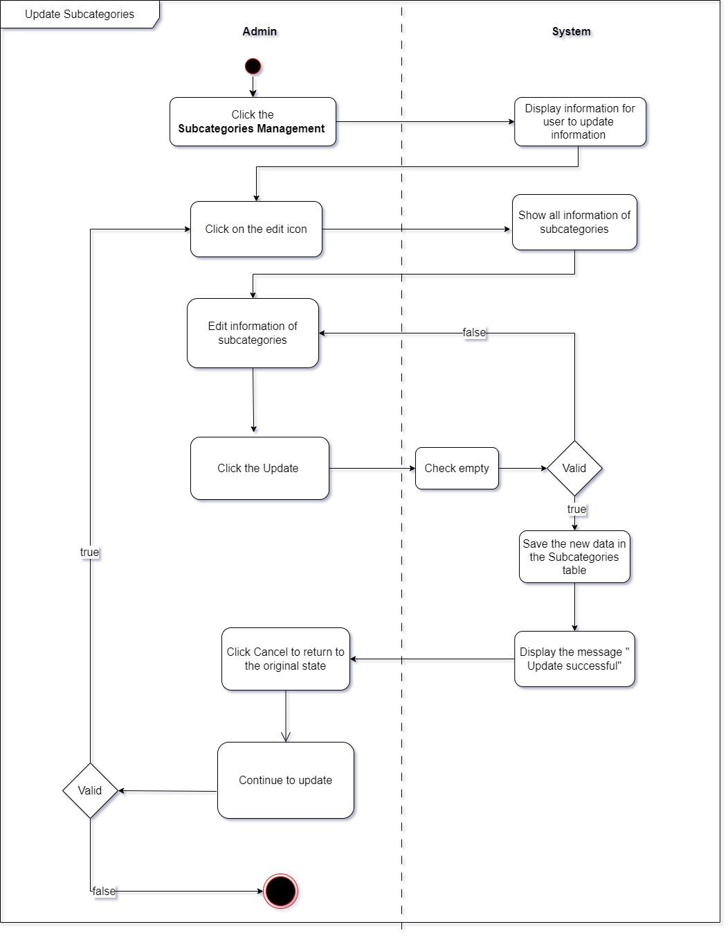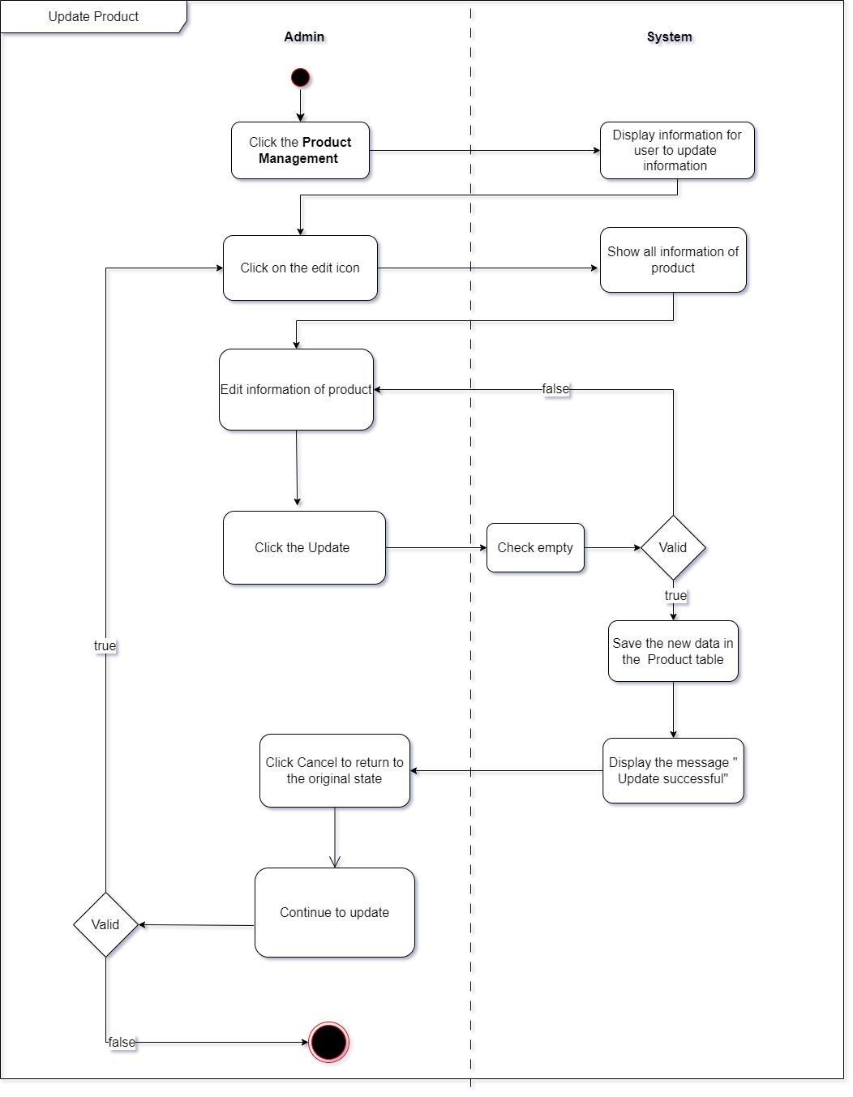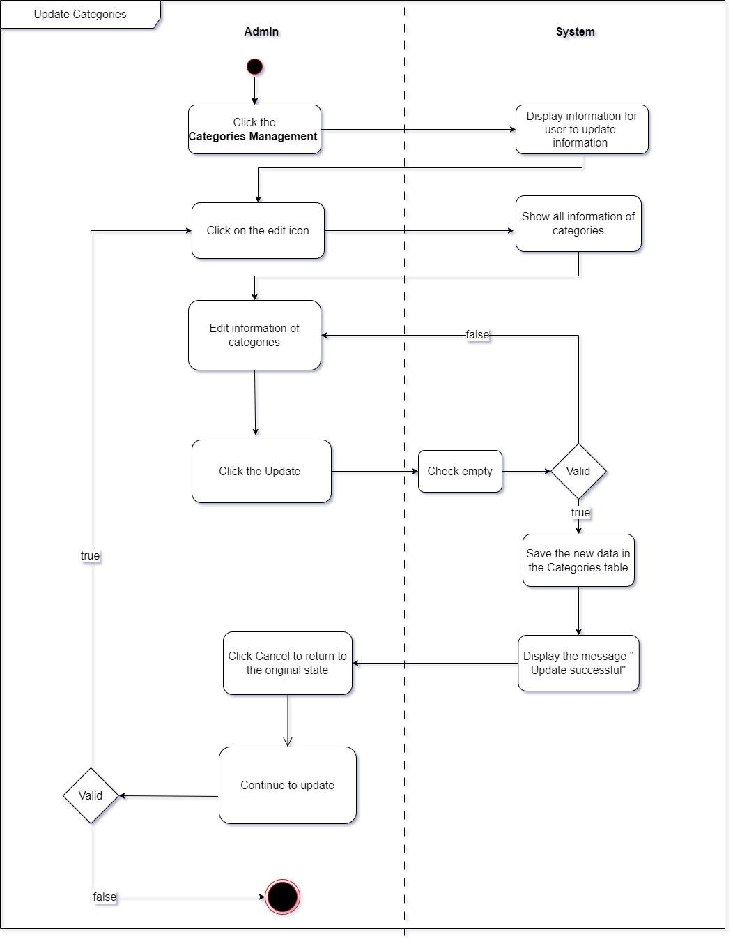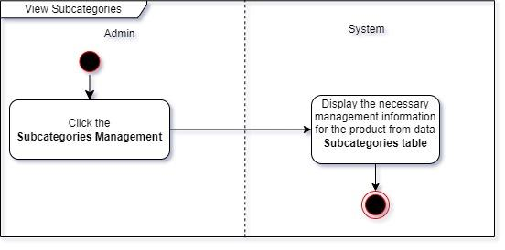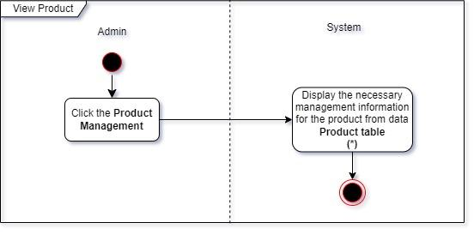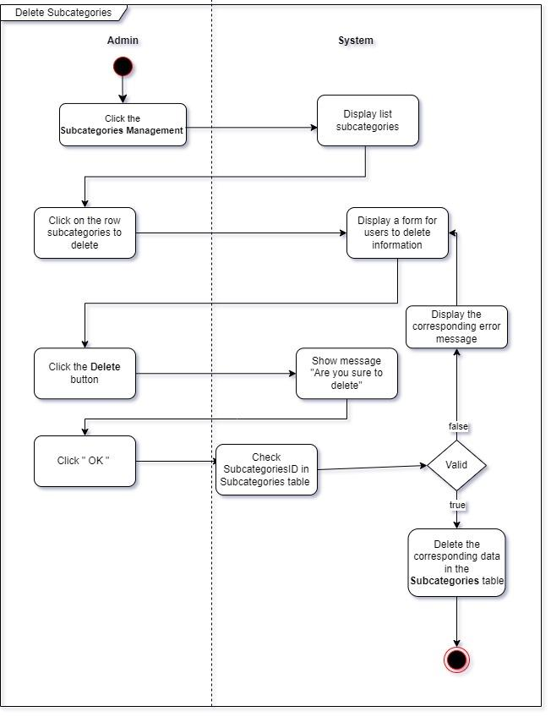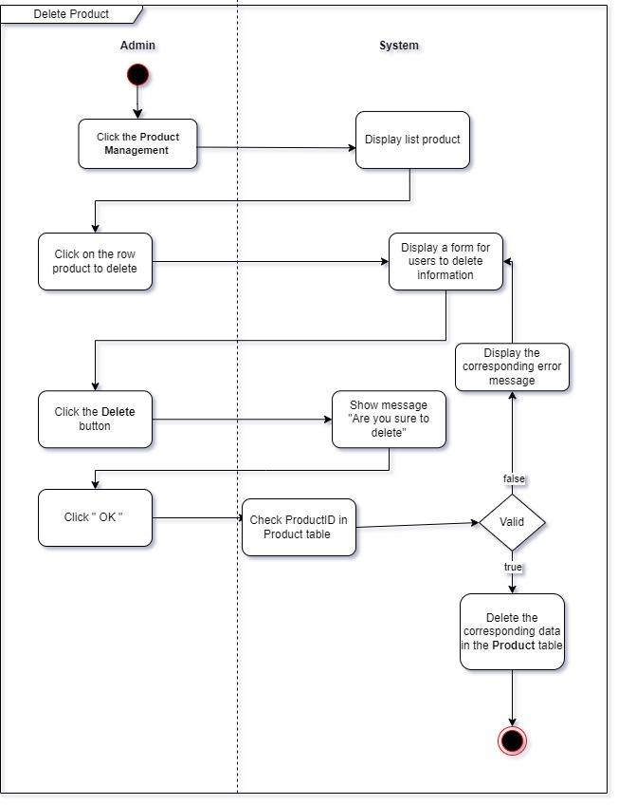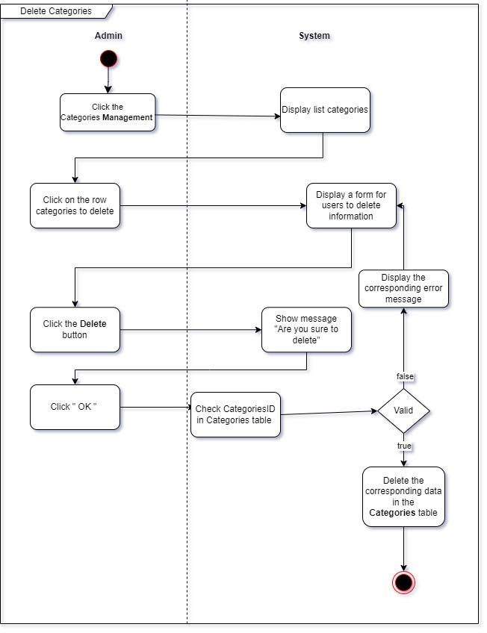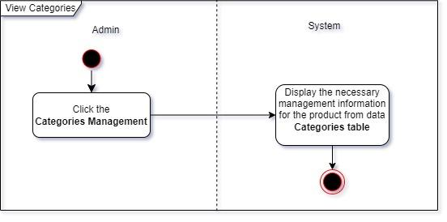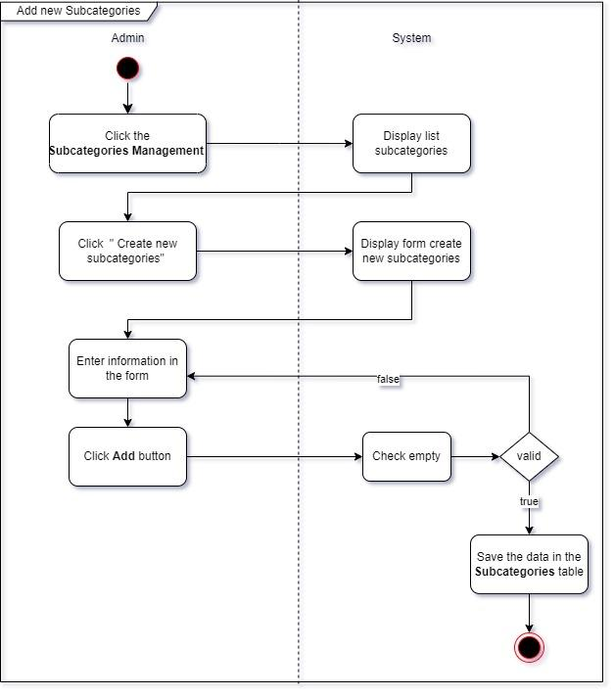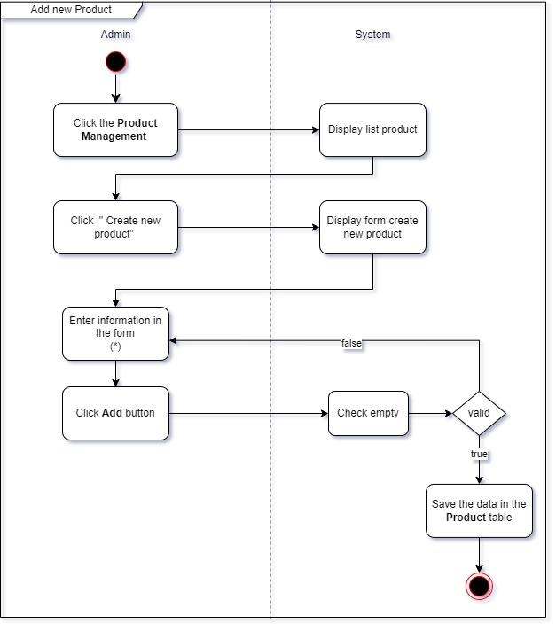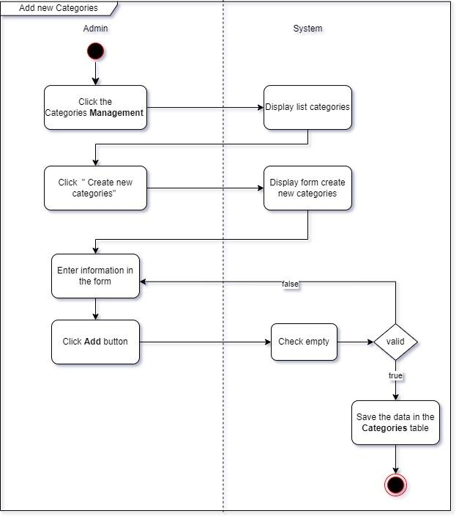

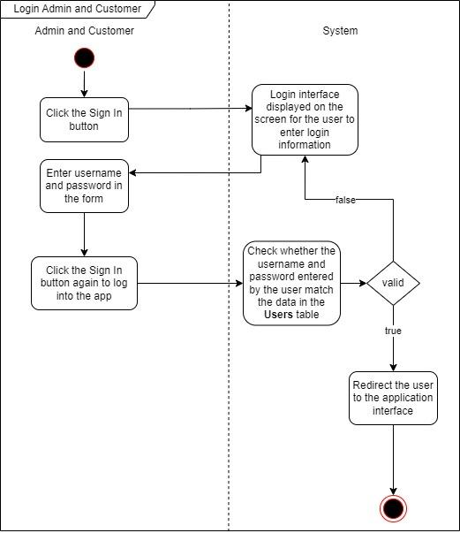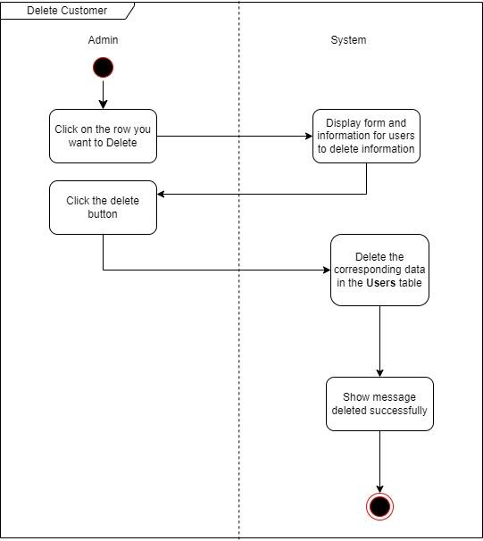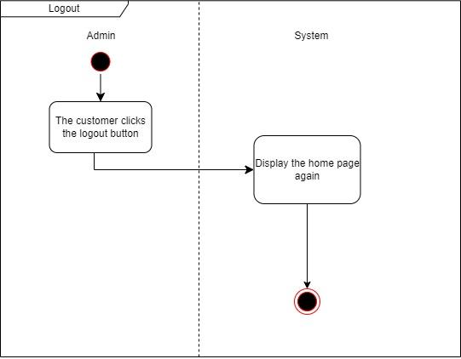 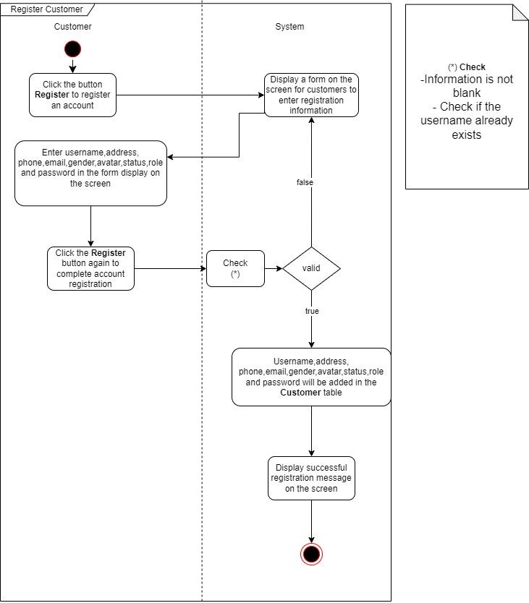 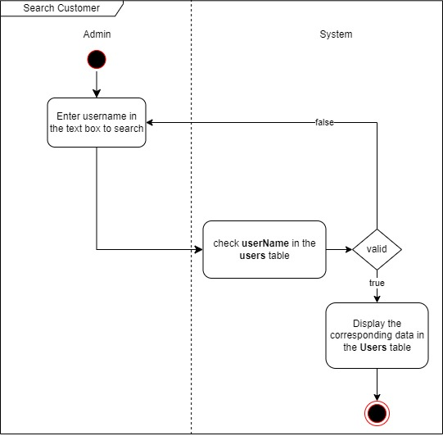 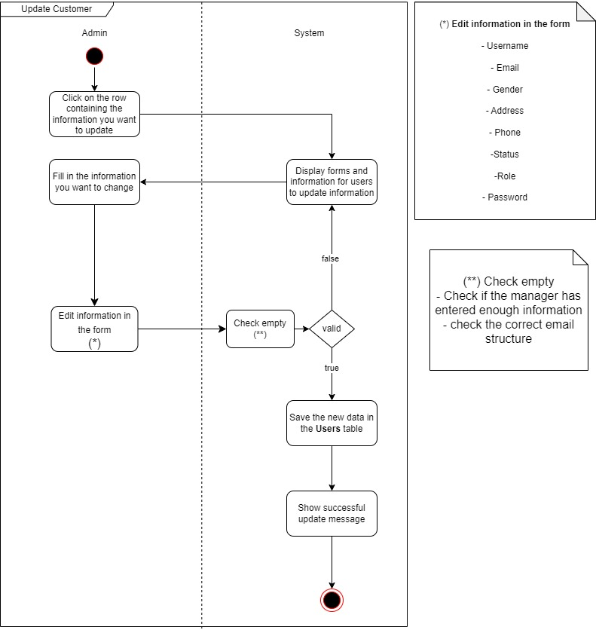

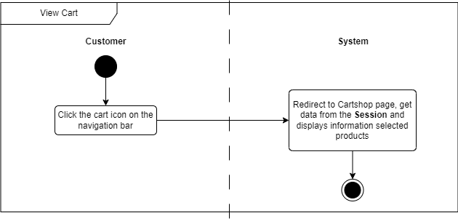

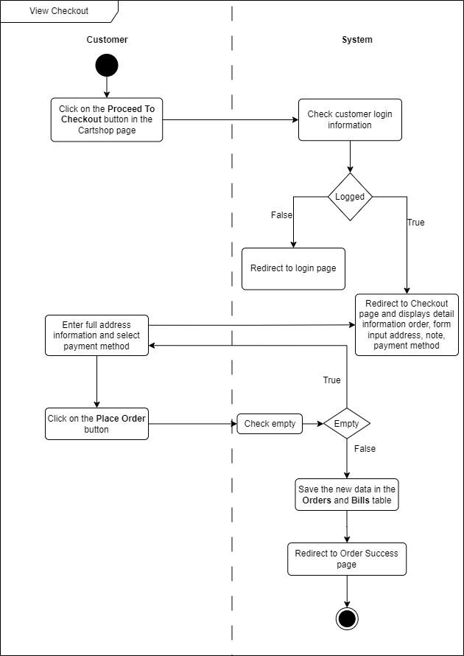

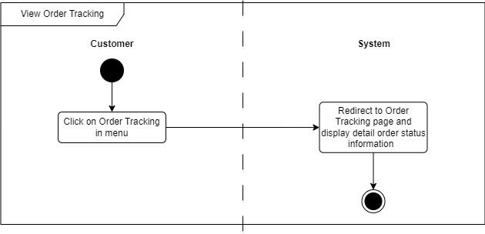

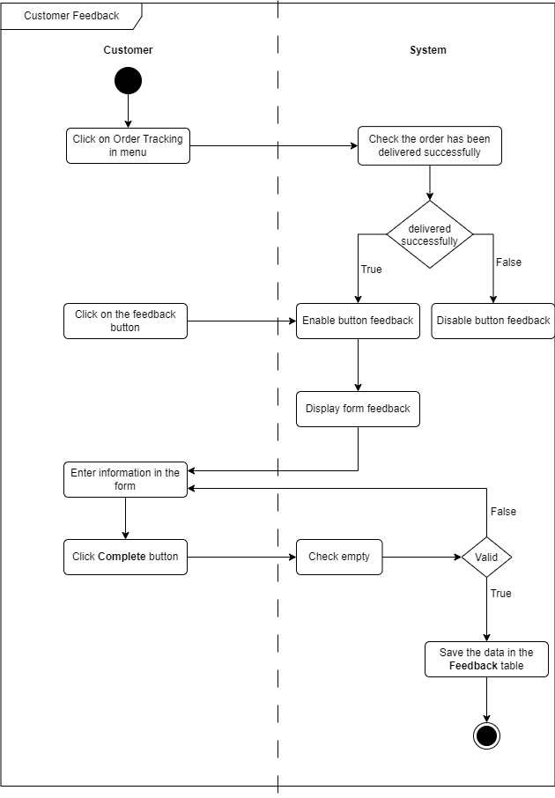

**3. Class diagrams:**

**Database Design/Structure:**

**I. ER/Class Diagram:**

**II. Table Description:**

|  |  |  |  |
| --- | --- | --- | --- |
| **suppliers** | | | |
| **Field Name** | **Data Type** | **Constraint  (Primary Key, Foreign Key, Identity, Not Null,...)** | **Description** |
| supplierID | Nvarchar(5) | Primary key | supplier code |
| supplierName | nvarchar(255) | Not null | supplier name |
| email | nvarchar(255) |  | email of supplier |
| phone | nvarchar(15) |  | phone of supplier |
| status | bit |  | status of supplier, 1:on, 0:off |
| website | nvarchar(255) |  | website of supplier |

|  |  |  |  |
| --- | --- | --- | --- |
| **authors** | | | |
| **Field Name** | **Data Type** | **Constraint  (Primary Key, Foreign Key, Identity, Not Null,...)** | **Description** |
| authorID | int | Identity(1, 1), Primary key | author code |
| authorName | nvarchar(255) | Not null | author name |
| email | nvarchar(255) |  | email of author |
| phone | nvarchar(15) |  | phone of author |
| description | text |  | description of author |

|  |  |  |  |
| --- | --- | --- | --- |
| **users** | | | |
| **Field Name** | **Data Type** | **Constraint  (Primary Key, Foreign Key, Identity, Not Null,...)** | **Description** |
| userID | int | Identity(1, 1), Primary key | user code |
| userName | nvarchar(255) | Not null | user name |
| email | nvarchar(10) | Not null | email of user |
| password | nvarchar(20) |  | password of user |
| phone | nvarchar(15) |  | phone of user |
| gender | bit |  | gender of user, 1 : male, 0 : female |
| address | nvarchar(255) |  | address of user |
| avatar | nvarchar(255) |  | avatar of user |
| status | bit |  | status of user, 1:on, 2:off |
| role | nvarchar(50) | not null | role of use |
| createAt | datetime |  | create at user |
| updateAt | datetime |  | update at user |

|  |  |  |  |
| --- | --- | --- | --- |
| **categories** | | | |
| **Field Name** | **Data Type** | **Constraint  (Primary Key, Foreign Key, Identity, Not Null,...)** | **Description** |
| categoryID | nvarchar(2) | Primary key | category code |
| categoryName | nvarchar(255) | Not null | category name |
| description | text |  | description of category |
| status | bit |  | status of category, 1:hot, 0:not hot |
| createAt | datetime |  | create at category |
| updateAt | datetime |  | update at category |

|  |  |  |  |
| --- | --- | --- | --- |
| **subcategories** | | | |
| **Field Name** | **Data Type** | **Constraint  (Primary Key, Foreign Key, Identity, Not Null,...)** | **Description** |
| subcategoryID | nvarchar(5) | Primary key, not null | subcategory code |
| subcategoryName | nvarchar(255) | Not null | subcategory name |
| description | text | Not null | description of subcategory |
| status | bit |  | status of subcategory, 1:hot, 0:not hot |
| createAt | datetime |  | create at subcategory |
| updateAt | datetime |  | update at subcategory |
| categoryID | nvarchar(2) | foreign key | category code |

|  |  |  |  |
| --- | --- | --- | --- |
| **products** | | | |
| **Field Name** | **Data Type** | **Constraint  (Primary Key, Foreign Key, Identity, Not Null,...)** | **Description** |
| productID | nvarchar(7) | Primary key | product code |
| productName | nvarchar(255) | Not null | product name |
| description | varchar(10) | Not null | description of product |
| avatar | nvarchar(255) |  | avatar of product |
| status | bit |  | status of product, 1:hot, 0:not hot |
| price | float |  | price of product |
| sale | float |  | sale of product |
| totalStar | float |  | total star of product |
| totalFeedback | int |  | total feedback of product |
| totalOrder | int |  | total order of product |
| createAt | datetime |  | create at product |
| updateAt | datetime |  | update at product |
| subcategoryID | nvarchar(5) | foreign key | subcategory code |
| authorID | int | foreign key | author code |
| supplierID | int | foreign key | supplier code |

|  |  |  |  |
| --- | --- | --- | --- |
| **orders** | | | |
| **Field Name** | **Data Type** | **Constraint  (Primary Key, Foreign Key, Identity, Not Null,...)** | **Description** |
| orderID | int | Identity(24000000, 1), Primary key, not null | order code |
| orderDate | datetime |  | order date |
| deliveryDate | datetime |  | delivery date |
| shipAddress | nvarchar(255) |  | ship address |
| note | nvarchar(255) |  | note |
| userID | int | foreign key | user code |
| paymentID | int | foreign key | payment code |
| deliveryID | int | foreign key | delivery code |

|  |  |  |  |
| --- | --- | --- | --- |
| **payments** | | | |
| **Field Name** | **Data Type** | **Constraint  (Primary Key, Foreign Key, Identity, Not Null,...)** | **Description** |
| paymentID | int | Identity(1, 1), Primary key | payment code |
| paymentName | nvarchar(255) | Not null | payment name |
| description | text |  | description of payment |

|  |  |  |  |
| --- | --- | --- | --- |
| **deliveries** | | | |
| **Field Name** | **Data Type** | **Constraint  (Primary Key, Foreign Key, Identity, Not Null,...)** | **Description** |
| deliveryID | int | Identity(1, 1), Primary key | delivery code |
| deliveryName | nvarchar(255) | Not null | delivery name |
| distance | float |  | distance delivery |
| price | float |  | price delivery |

|  |  |  |  |
| --- | --- | --- | --- |
| **bills** | | | |
| **Field Name** | **Data Type** | **Constraint  (Primary Key, Foreign Key, Identity, Not Null,...)** | **Description** |
| orderID | int | Identity(1, 1), Primary key | order code |
| productID | nvarchar(255) | Not null | product code |
| price | float |  | price of product |
| quantity | int |  | quantity of product |
| discount | float |  | discount of product |

|  |  |  |  |
| --- | --- | --- | --- |
| **FAQs** | | | |
| **Field Name** | **Data Type** | **Constraint  (Primary Key, Foreign Key, Identity, Not Null,...)** | **Description** |
| faqID | int | Identity(1, 1), Primary key | faq code |
| title | nvarchar(100) |  | title of faq |
| content | text |  | content of faq |

|  |  |  |  |
| --- | --- | --- | --- |
| **feedback** | | | |
| **Field Name** | **Data Type** | **Constraint  (Primary Key, Foreign Key, Identity, Not Null,...)** | **Description** |
| feedbackID | int | Identity(1, 1), Primary key | feedback code |
| content | text |  | content of feedback |
| createAt | datetime |  | create at feedback |
| numberStars | int |  | number star of product |
| userID | int | foreign key | user code |
| productID | nvarchar(7) | foreign key | product code |

**TASK SHEET**

|  |  |  |  |  |  |  |  |  |  |  |  |  |  |
| --- | --- | --- | --- | --- | --- | --- | --- | --- | --- | --- | --- | --- | --- |
| **Not.** | | **Task** | | **Estimated start date** | | **Actual start date** | | **Actual date** | | **Teammate's name** | | **Condition** | |
| 1. | Project problem definition | | 17/4/2023 | | | | 17/4/2023 | | 1 day | Nguyen Ngoc Bao Thi | Implement | | | |
|  | Customer Requirement Specification | | 18/12/2023 | | | | 20/12/2023 | | 2 days | Nguyen Duong Kieu Diem Quynh | Implement | | | |
|  | Database design | | 25/12/2023 | | | | 26/12/2023 | | 2 days | Dinh Huu Loc | Implement | | | |
|  | Use Case | | 26/12/2023 | | | | 27/12/2023 | | 2 days | Nguyen Ngoc Bao Thi | Implement | | | |
|  | Site map | | 26/12/2023 | | | | 27/12/2023 | | 2 days | Nguyen Ngoc Bao Thi | Implement | | | |
|  | Task Sheet | | 13/1/2024 | | | | 13/1/2024 | | 1 day | Nguyen Duong Kieu Diem Quynh | Implement | | | |
|  | Check List | | 13/1/2024 | | | | 13/1/2024 | | 1 day | Nguyen Duong Kieu Diem Quynh | Implement | | | |
|  | Database Design - Remake | | 20/12/2023 | | | | 20/12/2023 | | 1 day | Dinh Huu Loc | Implement | | | |
|  | Used Guide | | 12/1/2023 | | | | 13/1/2023 | | 2 days | Nguyen Ngoc Bao Thi  Dinh Huu Loc  Nguyen Duong Kieu Diem Quynh | Implement | | | |
|  | | Update products to home | | | 24/12/2023 | 25/12/2023 | | 2 days | | Nguyen Ngoc Bao Thi | | | Implement |
|  | | Product | | | 24/12/2023 | 24/12/2023 | | 1 day | | Nguyen Ngoc Bao Thi | | | Implement |

|  |  |  |  |  |  |  |
| --- | --- | --- | --- | --- | --- | --- |
|  | Product Detail | 25/12/2023 | 27/12/2023 | 3 days | Nguyen Ngoc Bao Thi | Implement |
|  | About us | 26/12/2023 | 27/12/2023 | 2 days | Nguyen Ngoc Bao Thi | Implement |
|  | Product management | 26/12/2023 | 26/12/2023 | 1 day | Nguyen Ngoc Bao Thi | Implement |
|  | Login | 27/12/2023 | 27/12/2023 | 1 day | Nguyen Duong Kieu Diem Quynh | Implement |
|  | Resgister | 28/12/2023 | 28/12/2023 | 1 day | Nguyen Duong Kieu Diem Quynh | Implement |
|  | Log out | 29/12/2023 | 29/12/2023 | 1 day | Nguyen Duong Kieu Diem Quynh | Implement |
|  | Decentralization | 27/4/2023 | 27/4/2023 | 1 day | Nguyen Duong Kieu Diem Quynh | Implement |
|  | Display customer information | 2/1/2024 | 3/1/2024 | 2 days | Nguyen Duong Kieu Diem Quynh | Implement |
|  | Contact | 2/1/2024 | 2/1/2024 | 1 day | Nguyen Duong Kieu Diem Quynh | Implement |
|  | FAQ | 3/1/2023 | 6/1/2024 | 4 days | Nguyen Duong Kieu Diem Quynh | Implement |

|  |  |  |  |  |  |  |
| --- | --- | --- | --- | --- | --- | --- |
|  | Customer Management | 2/1/2024 | 3/1/2024 | 2 days | Nguyen Duong Kieu Diem Quynh | Implement |
|  | FAQ Management | 3/1/2024 | 4/1/2024 | 2 days | Nguyen Duong Kieu Diem Quynh | Implement |
|  | Cart | 4/1/2024 | 4/1/2024 | 1 day | Dinh Huu Loc | Implement |
|  | Check out | 4/1/2024 | 5/1/2024 | 2 days | Dinh Huu Loc | Implement |
|  | Show order information | 5/1/2024 | 6/1/2024 | 2 days | Dinh Huu Loc | Implement |
|  | Order Management | 7/1/2024 | 7/1/2024 | 1 day | Dinh Huu Loc | Implement |
|  | Bill management | 8/1/202 | 8/1/2024 | 1 day | Dinh Huu Loc | Implement |
|  | Discount on number of code connections | 8/1/2024 | 8/1/2024 | 1 day | Dinh Huu Loc | Implement |
|  | Payment | 9/1/2023 | 11/1/2024 | 3 days | Dinh Huu Loc | Implement |
|  | Feedback management | 9/1/2024 | 9/1/2024 | 1 day | Dinh Huu Loc | Implement |
|  | Author management | 10/1/2024 | 10/1/2024 | 1 day | Nguyen Ngoc Bao Thi | Implement |
|  | Supplier Management | 11/1/2024 | 11/1/2024 | 1 day | Nguyen Ngoc Bao Thi | Implement |
|  | Subcategories management | 11/1/2024 | 11/1/2024 | 1 day | Nguyen Ngoc Bao Thi | Implement |
|  | Categories management | 12/1/2024 | 12/1/2024 | 1 day | Nguyen Ngoc Bao Thi | Implement |
|  | Validation checklist, submission checklist | 14/1/2024 | 14/1/2024 | 1 day | Nguyen Ngoc Bao Thi | Implement |
|  | Instructions for use | 14/1/2024 | 14/1/2024 | 1 day | Nguyen Duong Kieu Diem Quynh,Dinh Huu Loc,Nguyen Ngoc Bao Thi | Implement |
|  | Full website test | 14/1/2024 | 14/1/2024 | 1 day | Nguyen Duong Kieu Diem Quynh,Dinh Huu Loc,Nguyen Ngoc Bao Thi | Implement |
|  | Final Document | 14/1/2024 | 14/1/2024 | 1 day | Nguyen Duong Kieu Diem Quynh | Implement |
|  | Final Code website | 14/1/2024 | 14/1/2024 | 1 day | Nguyen Ngoc Bao Thi | Implement |
|  | Installation Guide | 14/1/2024 | 14/1/2024 | 1 day | Dinh Huu Loc | Implement |

|  |  |
| --- | --- |
| **Decision** | **Confirm** |
| Do all variables have a default value of 0? | Have |
| Does the administrator have all the permissions to create and delete records? | Have |
| Are all records properly included in the proper database? | Have |
| Are all modules properly integrated and fully operational? | Have |
| Have all Design and Coding Standards that have been adhered to and implemented | Have |
| Is the GUI design consistent? | Have |
| Is the navigation sequence correct through all forms/screens in the app? | Have |
| Is exception handling implemented in all monitors? | Have |
| Do all program codes work? | Have |

**Authentication checklist:**

**Submission checklist:**

|  |  |  |  |  |  |
| --- | --- | --- | --- | --- | --- |
| **Sr.NO**. | **Concrete** | **Have** | **Not** | **NA** | **Opinion** |
| 1. | Can all users search for a specific record? | Have |  |  |  |
| 2. | Are all old recordings saved and retrieved properly when required? | Have |  |  |  |
| 3. | Are all modules properly integrated and fully operational? | Have |  |  |  |
| 4. | Does the GUI content have typos? | Have |  |  |  |
| 5. | Is the app user-friendly? | Have |  |  |  |
| 6. | Is the project properly published to the setup file? | Have |  |  |  |

**Site map**

**Home page:**

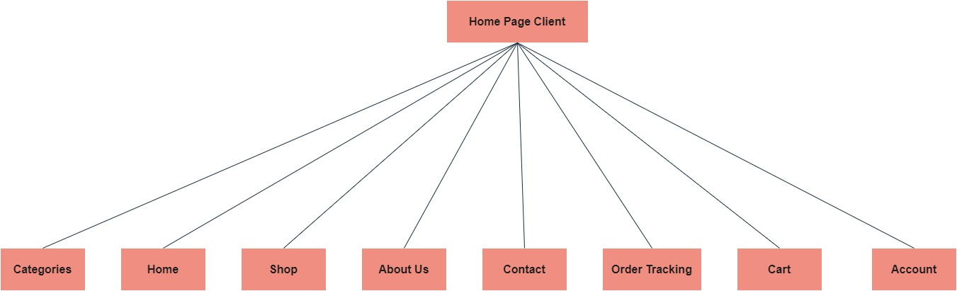+

Admin page:

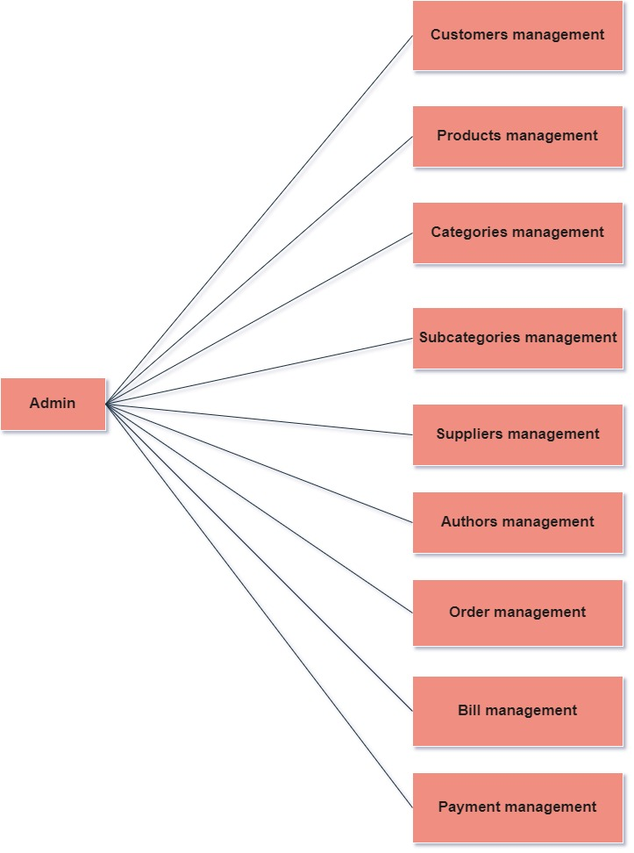

**INSTALLATION GUIDE:**

1. **System requirements :**

|  |  |
| --- | --- |
| **Items** | **Description** |
| Operating system | Microsoft Windows 10 or higher |
| Database | SQL server 2019 or higher |
| Software | Visual studio 2022 (ASP.NET MVC) |

1. **Install and Run Application:**

* **Step 1:**

Install SQL server 2019 on the local system.

* **Step 2:**

Create database with name “BookStore”.

* **Step 3:**

Open file SQL named “database-bookstore” and execute it.

* **Step 4:**

Open source code in visual studio and open file web.config in the root folder, edit connection string as below:

<connectionStrings>

<add name="BookStoreEntities"

connectionString="metadata=res://*/Models.BookStoreModel.csdl|res://*/Models.BookStoreModel.ssdl|res://*/Models.BookStoreModel.msl;provider=System.Data.SqlClient;provider connection string=&quot;data source=.;initial catalog=BookStore;persist security info=True;user id=sa;password=sa;MultipleActiveResultSets=True;App=EntityFramework&quot;" providerName="System.Data.EntityClient" />

</connectionStrings>

* **Step 5:**

Run application.

**Login account:**

* Customer account:

Email: kd@gmail.com

Password: 1234

* Admin employee account:

Phone: admin@gmail.com

Password: 123

**User manual:**

In this article, the team replaced the FAQ page by attaching a chatbot and here are the questions and answers. Which chatbot can offer to customers:

1.Can an Order be cancelled? If yes, will there be any charges?

- Yes, but if cancelled with in 24 Hrs. there will be no charges, but if cancelled after 24Hrs. and if the Order is being dispatched the Delivery charges for the to and fro is to be bared by the one who has ordered

2.How can I contact you?

- You can contact us at: 1 Đ. Ly Tu Trong, An Phu, Ninh Kieu, Can Tho, email: nnbthia22082@cusc.ctu.edu.vn,Phone number:+012 345 67890

3.How can I make sure the books I receive are new and not damaged?

- When you receive the book, please record a video. If the book is damaged or has any problems, please contact us for a return.

4.How many days will it take to deliver the order?

- Depends on the Order, Quantity and Stock and as well on the payment type chosen, as if the payment option chosen is payment before delivery, then the order will only be dispatched after the receipt of the payment.

5.How much does delivery cost?

- Regarding delivery costs from 0km-3km: free, from 4km or more will be charged $2/km

6.What if the order delivered is not in proper condition?

- If the order delivered is improper, it will be replace with the other.

7.Will there be any charges for the delivery apart from the products ordered?

- No

8.How can the payment be made?

- Please shop on our website, in the shopping cart there will be a product payment section, you can pay there.

And in this article, the Customer Management, Author, Product,... sections can all be exported to excel, pdf, print, csv files. Columns can be hidden when the web screen is minimized.